**CardBook**

4952 Tech Pro – Low Fidelity Prototype

**Interface Description:**

CardBook is a web application that manages discount offers and the stamp card offered by different companies. The benefit of this system is to avoid collecting numerous of thick, worn-out cards in everyone’s wallet. User can simply login to the web application from their mobile or home device and look up the currently available discount and collect virtual discount cards, offered by companies, in their account.

Every company that desires to use our service will have their own section in the website. For each company profile, they will have a discount offer section that lists all of their offers and an optional stamp card option that they can take advantage of. We will manage their offers and update their section as they request. The stamp card feature is a customer appreciation system. The companies can create and design their own virtual stamp cards. They can distribute these virtual cards when customer purchases certain items in store. The only requirement is that the user will need a CardBook account to collect such cards. When the customers accumulate the required amount of stamps specified by a company, they will be able to redeem the card once for some sort of deal. The customer can start a new stamp card after they have completed an old one.

**Interface Design and Requirements:**

1. Responsive Interface that works on multiple devices (tablets, smart phones, desktop)
2. Registration Page for users who wants to collect stamp cards and look up company deals
3. Home Page with all different company deals (Category sort, deals of the week sort etc.)

* Sorts will be implemented for easy access to different types of companies
* Deals of the week sort will show the best deals of that week
* These sort will help users to navigate faster to the things they want to see

1. Staff Add / Delete / Redeem Card Page

* Add stamp function is the basic core function of the stamp card. Allows company staff to give credit to the customer’s purchase. This will help attract more customers for that company.
* Delete function is there just in case a refund was done by the customer
* Redeem function allows customer to redeem their fully stamped card.

1. User Login Page (View their collected stamp cards)

* A web page that displays all cards accumulated by that customer
* This page must be simple and not cluttered.

1. Database for user assets and company assets

* User DB include: personal information table, stored stamp card table
* Company DB include: Company Information table, Offers Table, Stamp Card table

1. Search function for company stamp cards

* This function is necessary in 2 places:
* Homepage where all company deals are shown
* User login page where accumulated stamp card are shown (might need search if many stamp cards are stored)

**Task Analysis:**

|  |  |  |  |  |
| --- | --- | --- | --- | --- |
| ***Customer Task Analysis*** | | | | |
| Sub Tasks | **Register for an Account (Intended for first time user)** | **Login to check Stamp Card (User)** | **Logout** | **Browsing deals offered by different company** |
| Scenario | I would like to use the discount and stamp cards offered by different companies. I figured that I need an account from Cardbook to take advantage of the offers. | I had a good day at the shopping mall today. I got a stamp from the café, wal-mart, and coach. I want to know if its registered in my account. | I am done checking everything. I need to log out so my information is secured. | I heard from my friend that there are discounts at my favorite store today. I should go to cardbook to see what deals they are offering |
| Consideration / Influences | Do I need to provide personal information? Credit Card? Do I need a paid subscription? Does it work for the xxxxxx company that I always go to? Is the system easy to use? | Do I need to setup anything before I can check my stamp cards? How accessible is my account info? Can I do it in my mobile devices? |  | I hope there is a search function so I can find the store I want to visit easily. Are the deals labeled on the website 100% accurate? |
| Pain-Point | One more account that I need to remember about. | I wish there is an app that I can launch to see all my stamp cards. Instead of logging in everytime. |  | Everything will need to be searched by users. Email updates would be great. |
| Functionality | 1. User access to cardbook home page. 2. Clicks registration button from home page 3. Types in personal information: name, e mail address and password 4. Confirm registration via their e mail 5. End of workflow | 1. User access to cardbook home page 2. Clicks login button from home page 3. Type in user name and password 4. Go into account information 5. User will now be able to check all accumulated stamp cards 6. End of Workflow | 1. Continue from previous workflow 2. Click logout button to logout 3. End of Workflow | 1. User access to cardbook home page 2. Login is optional to view all deals on cardbook 3. From the main panel user can choose different sort options to display company or deals 4. The category includes : Deals of the Week, Company from A-Z, Hottest Discount, Today only deals etc. 5. The result will be displayed in a panel directly below it with easy to understand logo 6. End of workflow |

|  |  |  |  |
| --- | --- | --- | --- |
| ***Company Task Analysis*** | | | |
| Sub Tasks | **Login as Company Account** | **Add stamp, Delete stamp, and redeem stamp card for customers** | **Adding additional deals to their company section** |
| Scenario | I would like my company offers to be shown in cardbook. I would also like to take advantage of their stamp card system. I need an account. | A customer is paying for their service / product. She qualifies for a stamp card and we need to add a stamp to their account. | I have a new offer I would like my customers to know about. I must add this deal to the cardbook web app. |
| Consideration / Influences | Where should I go about doing it? I don’t see a company registration. How long will it take for my account to be set up? | My company is always busy, Is the system fast and easy to use? Will it interrupt my business such that I lose sales? | What do I need to prepare for a procedure like this? Will the cardbook staff advertise the deal information correctly? |
| Pain-Point | Everything needs to be handled by the cardbook. I have very little control over my account. | My staff needs to apply stamps and take payments at the same time. This is an additional task. | Companies will have no control over updating their deals (at this moment) |
| Functionality | 1. Companies do not need to register for an account. Account will be made for them 2. User access to cardbook home page 3. Clicks login button from home page 4. Type in user name and password 5. End of Workflow (Continue to Add and Delete Stamp Functionality for Customers) | 1. A customer has satisfied the requirement to get a stamp 2. Staff will login (stays logged in after the first time) 3. A simple page will load for company accounts 4. This page contains add stamp, delete stamp and redeem card buttons 5. Staff will ask for customer cardbook ID and enter it into the page and click the appropriate button 6. End of Workflow | 1. Create a description of the deal, a 400 x 200 thumbnail, start and end date 2. Submit all this information to CardBook Support 3. CardBook support will update site with this new information 4. End of workflow |

***Issues and Risks:***

1. One of the foreseen issues could be the POS (Point of Sale) system in a store. The user may need to use their POS in conjunction with our web app. This may prove troublesome.
2. We see the risk in implementing a QR code reader into our web application. This might prove to be too much work for our time line and we aren’t sure if a QR code works well with our desired system. Since we will need to protect non customer from using this QR code to get discount and deals.
3. Cashier need to spend extra time utilizing our web app and giving customer’s their entitled deal. This is inevitable in any system that have a purpose, but it can be an issue in a busy environment such as McDonalds or Tim Horton’s.
4. Another foreseeable issue is the convenience of our web application. We try to design our web application with the idea of utilizing the least steps.
5. Minimal ASP.NET, CMS, and MVC skills.
6. Minimal jQuery, Javascript, and CSS skills.
7. Completion of all requirements that we have planned in this time frame.

***Low Fidelity Design:***

Registration Page

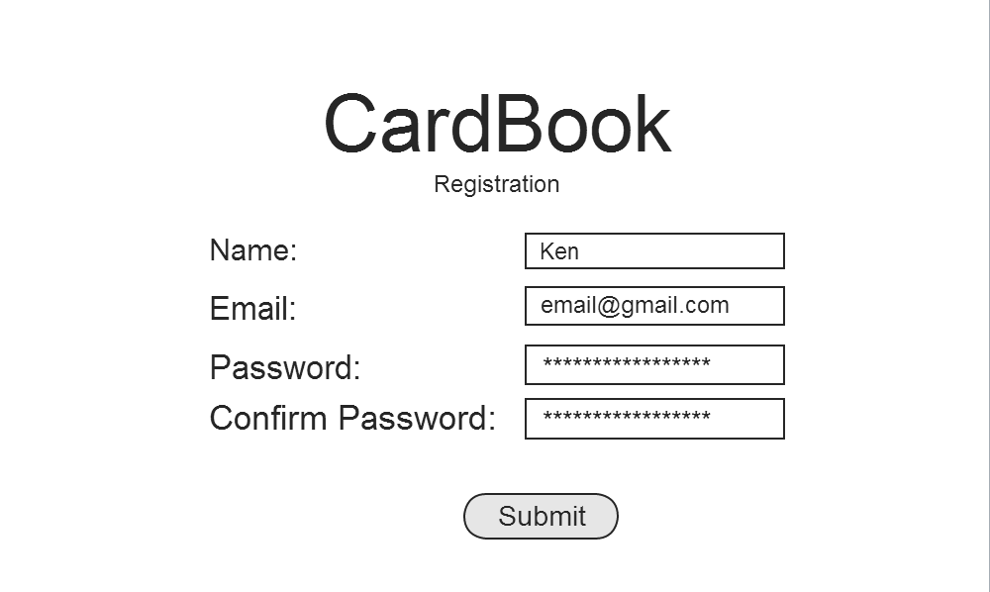

Home Page with different Company Deals displayed

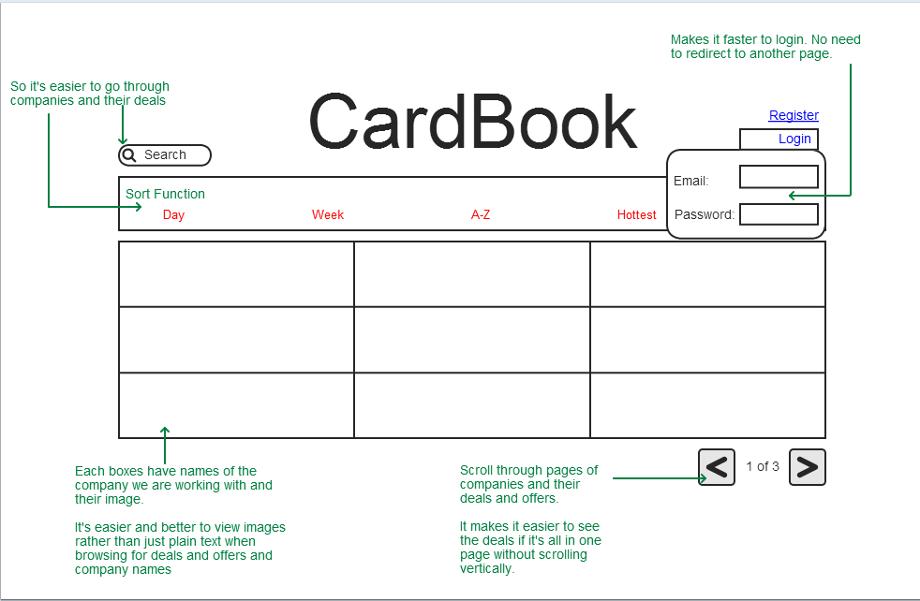

Page to check what cards have been accumulated by the user

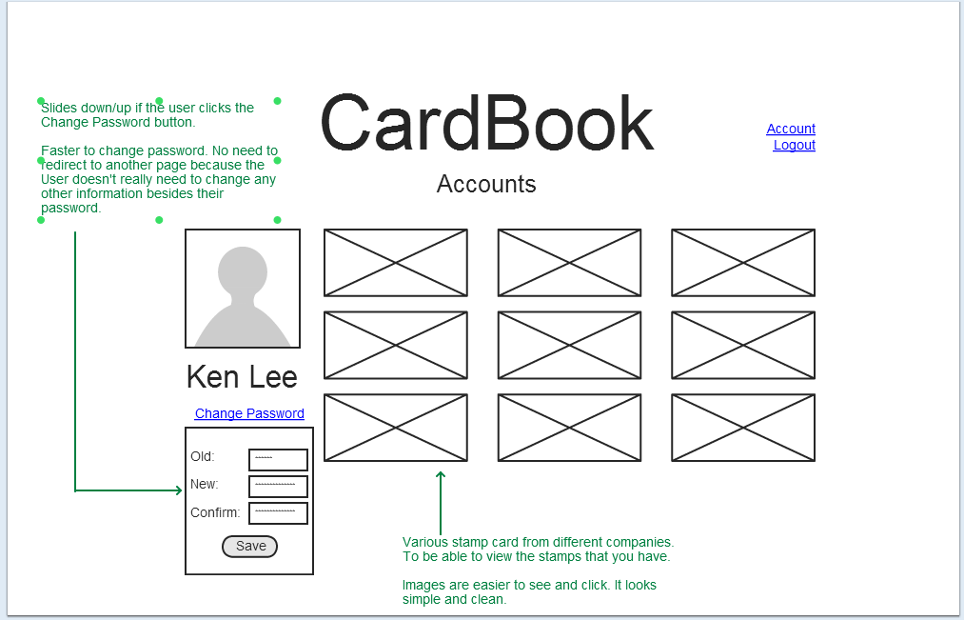

Company Page Only (Allow staff to stamp Customer’s virtual card)

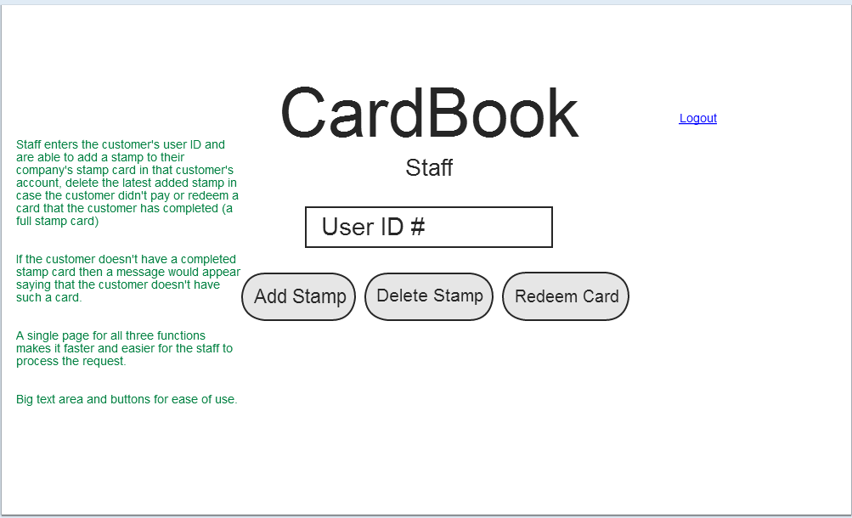

**Justifications of user-centered design**

We have two types of users: **staff** who serves the customers and **customers** who use our application for deals and stamp card.

**Visibility of system status (Feedback)**

The system should always keep users informed about what is going on, through appropriate feedback within reasonable time.

* For customers, this heuristic does not apply because the main purpose of the web app for them is to browse for deals and offers and view the status of their stamp cards. They won’t be doing anything that needs confirmation or feedback message.
* For the staff, if they type in a customer’s id to redeem a card and the process was successful, we will have a message indicating so. This also applies if the process fails such as the customer has no redeemable cards or the customer id doesn’t exist.

**Match between system and the real world**

The system should speak the users' language, with words, phrases and concepts familiar to the user, rather than system-oriented terms.

* For customers, we will provide many images for navigations rather than text-based links. Therefore, the web application is very self-explanatory.
* For the staff, we labeled the buttons on the staff page as “add stamp”, “delete stamp”, and “redeem cards”. This is because these are what the staff would do if they are dealing with a physical stamp card.

**User Control and Freedom**

Users often choose system functions by mistake and will need a clearly marked “emergency exit” to leave the unwanted state without having to go through an extended dialogue.

* For customers, this heuristic will not be applied as they will not be updating or submitting anything that can result in an undesirable state. The customers are only allowed to change their password and it already has an error prevention mechanism where the customers have to re-type their new password again to confirm that it was the same as the one they typed in earlier, preventing them from typing an incorrect new password.
* For staff, we have a “delete stamp” button. This is for cases like when the customer doesn’t pay or cancels their order but the staff has already added a stamp on their card, the staff can then use the delete button to delete the latest added stamp for that customer.

**Consistency and standards**

Users should not have to wonder whether different words, situations, or actions mean the same thing. Follow platform conventions.

* For the customers, when they go to our homepage to browse for deals and offers, we used arrow signs as labels for our buttons instead of “next” and “previous” indicating next and previous page. It is common knowledge outside our website that the left arrow means previous or back and the right arrow means next. It is also faster to see a sign rather than read a text.
* For the staff, this heuristic will not be applied as they only have one page they use to interact with our web application called the staff page. The staff page is very simple with only 3 buttons and a text field and therefore they will not have any confusion.

**Aesthetic and Minimalist Design**

Dialogues should not contain information, which is irrelevant or rarely needed. Visual layout should respect the principles of contrast, repetition, alignment, and proximity.

* For the customers, to help them get used to the layout as quickly as possible, the style of the whole website will be consistent around all the pages. The pages will be centered to the screen, our website logo on top and contents of the page below that. We will also limit the usage of colors around the whole website so it won’t be too harsh on the eyes.

We will also use a next/previous button style to navigate between deals and offers in the homepage as opposed to listing them out vertically. This lessens the need for scrolling and it is more visually appealing.

For the list of deals and offers, we will present them as images on our homepage. The images will have a text of the deal, an image that relates to the deal and the name of the company offer. For example, the image for a 30% off sushi from a restaurant called Sushi King will have the text “30% off”, “Sushi King”, and an image of a sushi. This is more visually appealing and it is faster to recognize images rather than text. If a customer was looking for a discount or deals on skirts, they can easily find the deals because they can see the image of a skirt.



Example of a deals image

* For staff, the layout of the staff page will only consist of “add stamp”, “delete stamp” and “redeem card” buttons plus a text input area because the intent of the staff page is just to add stamps, delete stamps and redeem cards. This will help speed up the process for the staff as there are no unnecessary images or text and the staff can easily locate the buttons they need.

**Error Prevention**

Even better than good error messages is a careful design which prevents a problem from occurring in the first place

* We chose to use ASP.NET MVC as the framework of choice. The separation of responsibilities in each component allows us to test the code independently, future enhancements and other maintenance of the code would be very easy, and the code base is easily reusable. By utilizing the model, view, and controller correctly, we will be able to create a more bug free application.

**Recognition rather than recall**

Minimize the user's memory load by making objects, actions, and options visible.

* We do not have many complex dialogues or pages in our design. Everything is mostly done on a page without requiring a separate window therefore we will not be following this design heuristic.

**Flexibility and efficiency of use**

Accelerators – unseen by the novice user – may often speed up the interaction for the expert user such that the system can cater to both inexperienced and experienced users.

* For the customers, they will have the option to look through every page if they choose to. Search bars and sorts will also be present in deal section and stamp card section to allow for quick look ups.
* This heuristics does not apply to staffs. We will not be having any accelerators or shortcuts as our design is very simple already and does not have a need for any shortcuts.

**Help users recognize, diagnose, and recover from errors**

Error messages should be expressed in plain language (no codes), precisely indicate the problem, and constructively suggest a solution.

* When registering for an account, the user will be alerted if their passwords are too short or if their passwords do not match. Messages will be precise such as “Passwords must be at least 8 characters long” or “Passwords do not match”.
* This heuristics does not apply to staffs. We will have error messages displayed for the staff if a stamp could not be added, deleted, or redeemed. However, the staff will need to contact card book for further diagnoses and recovery of the problem. **Note: we should have an easy, one button error reporting system for staff when such event occurs.

**Help and documentation**

Even though it is better if the system can be used without documentation, it may be necessary to provide help and documentation.

* We will provide a Frequently Asked Question (FAQ) section to help customer navigate their way through the website.
* This heuristic does not apply to staffs. Staff will only interact with add stamp, delete stamp, and redeem card page and the page was designed for efficiency with no other extraneous information. Once the staffs understand the concept of the stamp card, everything else will be self-explanatory.